Lab 3

# WAP to show the use ADO.NET in your .NET Program with either ASP.NET Web Forms Project or ASP.NET Core MVC Project.

## Create Database and Table in SQL Server

Query to create database: **Create database Lab3db**

Query to create table:

CREATE TABLE dbo.Employee (

Id int IDENTITY(1,1) NOT NULL,

EmployeeName nvarchar(100) NULL,

Department nvarchar(50) NULL,

Salary nvarchar(50) NULL,

JoinedOn date NULL,

)

## Create a form to get user data input and insert into table

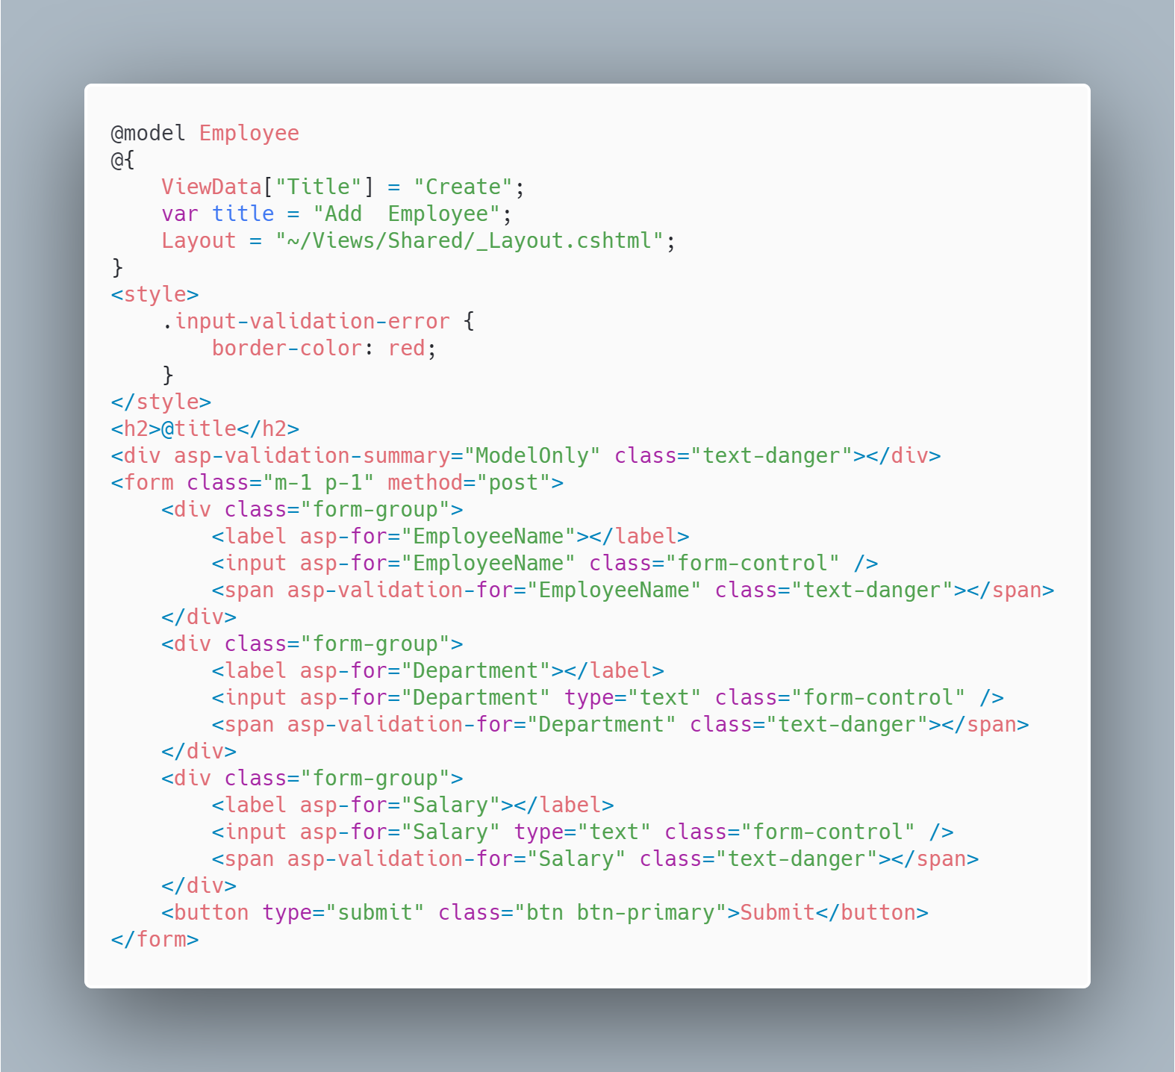

## Show Data from your table in your list page.

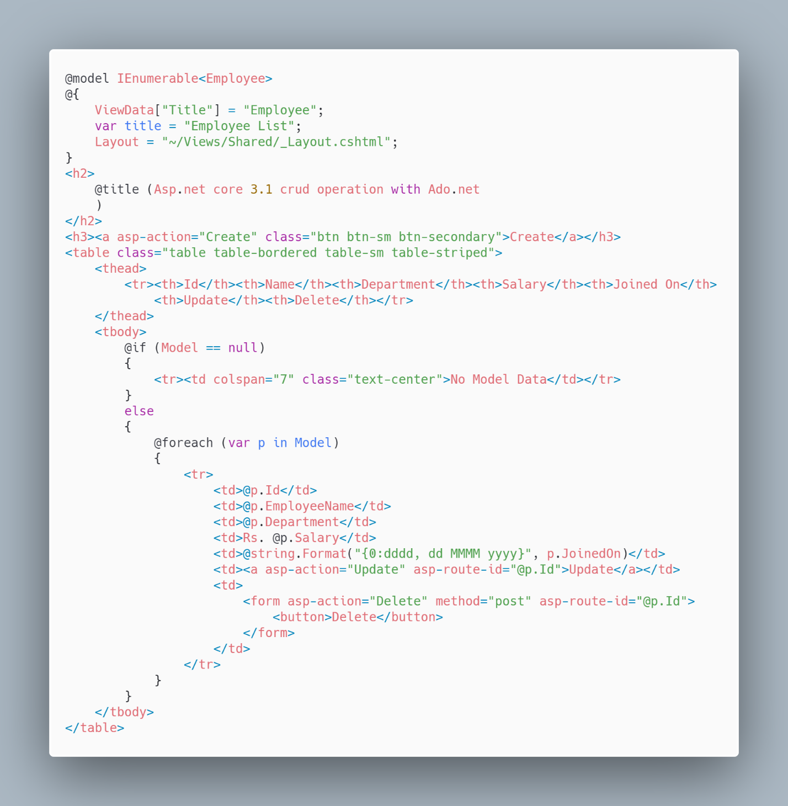

## Update Data through your edit page

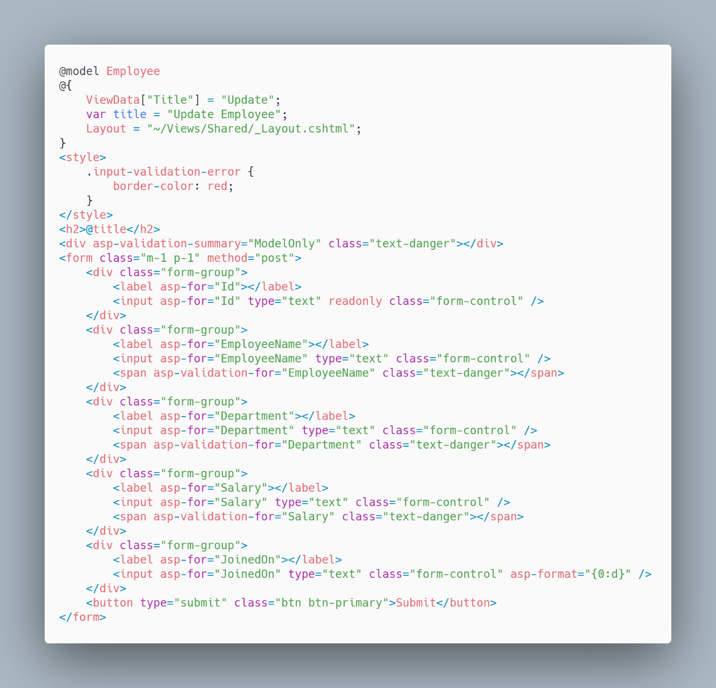

## Delete a row of data from your given input data.

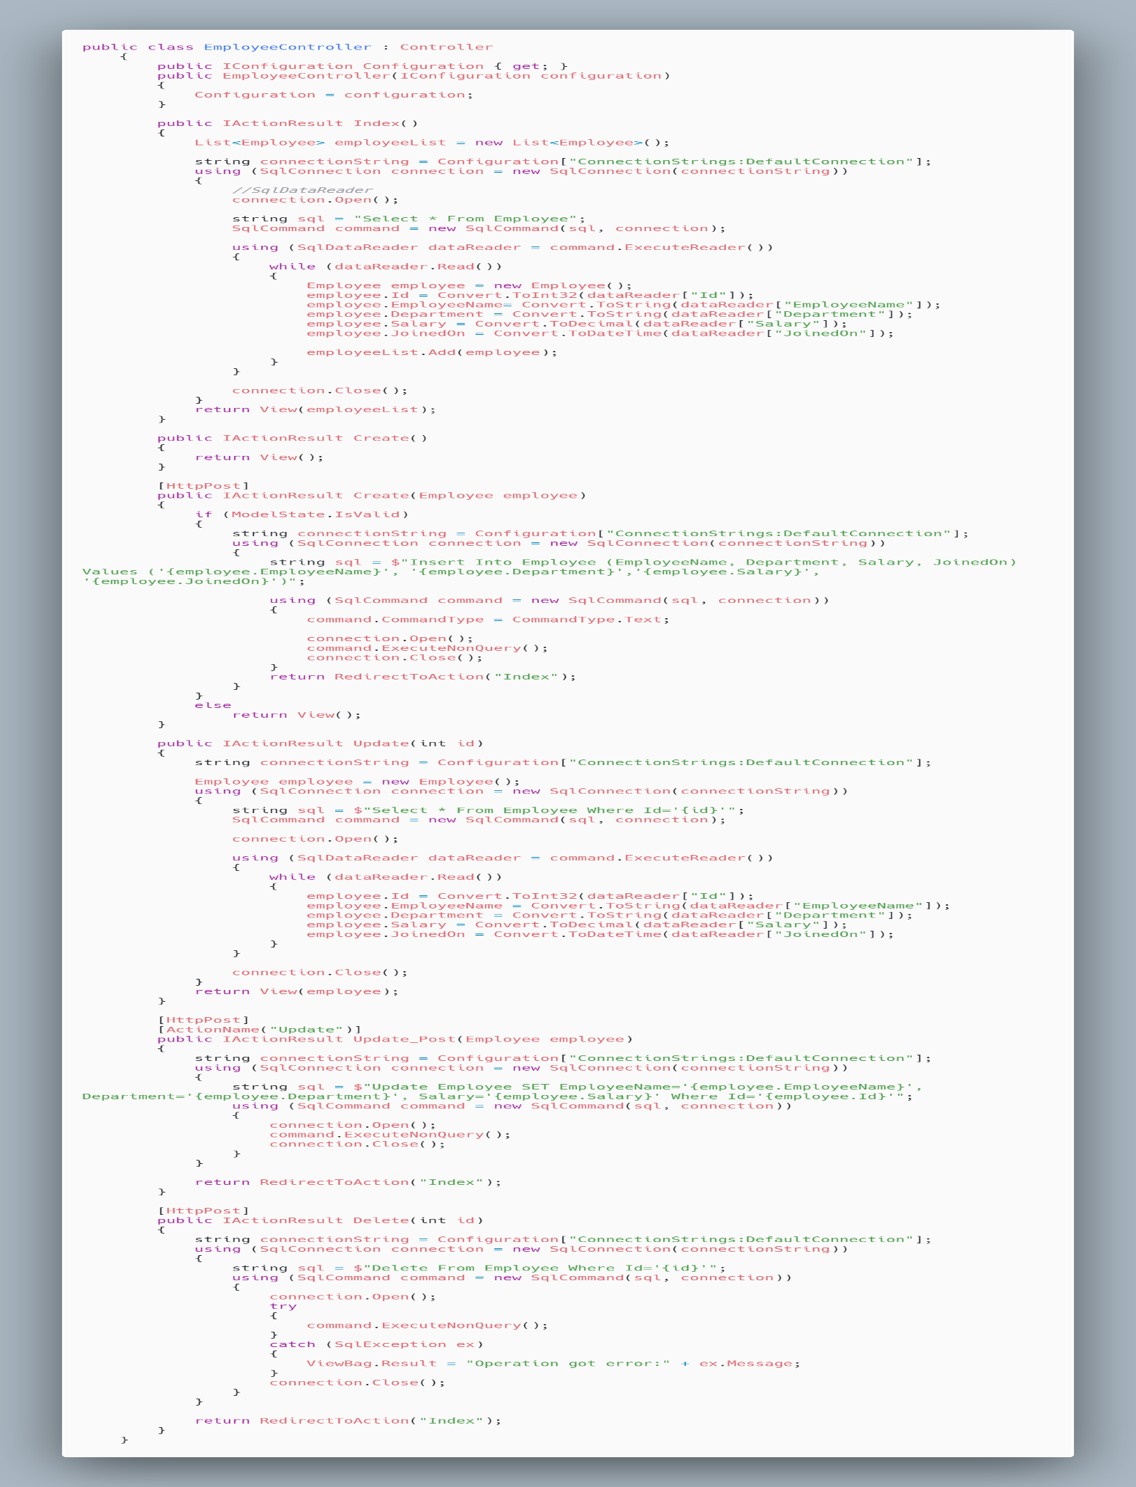

*Hint: Given below is for your reference. But do not create same table name and model presented.*

<https://tutorialshelper.com/asp-net-core-3-1-crud-operation-with-ado-net/>

Connection String : “Data Source=.;Initial Catalog=Lab3db;Integrated Security=True”

# Create a new ASP.NET Core MVC Project using Entity Framework. Show with each step along with screenshot.

## Add Necessary Nuget Packages

## Create Model Class

## Generate Database and Table

## Create Controller and views using Entity Framework

## Explain your code in Controller and views